Katherine Hackett Oracle SQL Foundations 1,2,3,4



Exercise 1: Identify Database Design Considerations for Given Case Scenarios

Overview

In this practice you will evaluate the data that needs to be captured to build a simple and efficient

•Student Registration System

•Library Management System

Tasks

1.ABC School District would like to create a student on-line information and registration system to capture student-related information. The system needs to be designed as an on-line process to allow all new students to register on-line. It should also allow existing students to update and review all information. Create a list of important data that would need to be captured and stored in the student registration database.

* Student name, address, DOB, entering grade for fall of 2024
* Parent contact information such as name(s), relationship, phone, email, address, marital status
* Student’s school-issued email address, homeroom, class schedule
* Sports, clubs, previous academic history, credits earned, credits needed for graduation
* Student bus information, textbook pickup location
* Emergency contact information, allergies, contacts for doctors/dentist

2.XYZ community would like to create a library management system. The objective is for the database to handle all transactions for the library. The database needs to store all the data that is relevant to managing the books, managing customers, and the day-to-day activities of the library. Create a list of important data that would need to be captured and stored in the library management database.

* Titles, authors, ISBN numbers, dewey decimal system ID number for local library, year of publication
* Customer names, emails, phone numbers, addresses, library card number, expiration dates
* Customer RSVPs to events, their interests, historical data on their library borrowing history
* Staff names, emails, phone numbers, addresses, date of employment
* Event name, date, location, start and end time, method of invitation, RSVP collection
* Program calendar with events, business hours, staff schedules
* Lists of subscriptions to magazines, newspapers, databases, etc.

Database Foundations

1-3: Types of Database Models

Practices

Exercise 1: Identify the Database Models

Overview

In this practice you will identify the type of database model depicted in the given model snapshots.

Tasks

1. Identify the type of database model that has been represented in the given model snapshots:

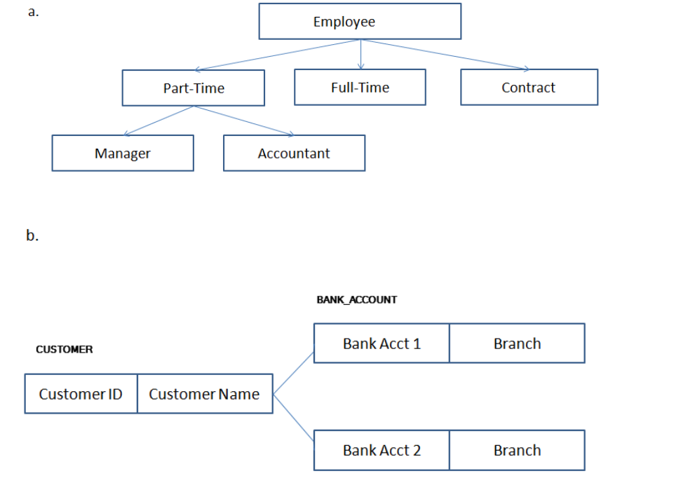

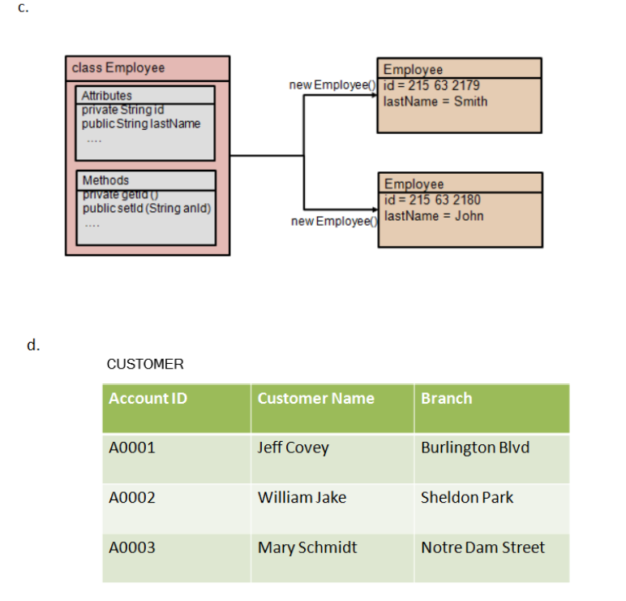

A: Hierarchical Model

B: Network Model

C: Object-Oriented Model

D: Flat File Model

Database Foundations

1-4: Business Requirements

Practices

Exercise 1: Business Requirements

Overview

In this practice you will analyze the case scenario provided and identify business rules.

Tasks

1.LibBook is a successful digital library that rents CDs and provides access to Internet for browsing their repository of articles and magazines. With the growing business, LibBook needs to enhance their information system to support proposed changes to the business. LibBook attracts new members easily and the number of members is growing rapidly. The membership base is not stable, however, which is a cause for concern. The main idea is to introduce the concept of membership at LibBook. Members will pay a membership fee and initially, there will be three types of membership (corporate, student, individual) although more may be introduced later. Student membership is free. Corporate and Faculty memberships incur a fee but entitle the member to privileges.

The type of membership can be changed only if sufficient justification is provided.

Your task is to identify the business rules and the associated constraints from the case scenario described.

* Business Rule: Corporate and individual members will pay membership fees
* Business Rule: student membership is free
* Constraint: Members can belong to one of the three types of membership (corporate, student, individual)
* Constraint: members can only change membership level with sufficient justification

2.Star Care hospital is a multi-specialty hospital that caters to needs of different patients. Every doctor registered with this hospital is assigned a unique ID that starts with the letter "DC". The hospital ensures that the doctors associated with them have a minimum of seven years of working experience. Every patient is required to register with the hospital on their first visit. When a patient arrives, a unique patient number starting with the letters "PT" is assigned to him/her.

Your task is to identify the business rules and the associated constraints from the case scenario described.

* Business Rule: Every doctor registered with this hospital will be assigned a unique ID starting with DC
* Business Rule: Every patient registered with this hospital will be assigned a unique ID starting with PT
* Constraint: Patients must register in the system upon their first hospital visit
* Constraint: Every doctor registered in the system must have a minimum of 7 years experience

Database Foundations

2-1: Relational Databases Practices

Exercise 1: Analyze the features of a Relational Database

Overview

In this practice you analyze the features of multiple table databases from a set of examples.

Tasks

1.Identify the possible tables and associated fields from the given scenario: Book.com is an online virtual store on the Internet where customers can browse the catalog and select products of interest.

a.Every book has a title, ISBN, year and price. The store also keeps the author and publisher for any book.

* Book_ID, Title, ISBN, Year, Price, Author_ID, Publisher_ID

b.For authors, the database keeps the name, address and the URL of their homepage.

* Author_ID, Name, Address, Homepage_URL

c.For publishers, the database keeps the name, address, phone number and the URL of their website.

* Publisher_ID, Name, Address, Phone, Website_URL

d.The store has several warehouses, each of which has a code, address and phone number.

* Warehouse_ID, Code, Address, Phone

e.The warehouse stocks several books. A book may be stocked at multiple warehouses.

* Warehouse_ID, Book_ID, Stock_Quantity

f.The database records the number of copies of a book stocked at various warehouses.

* Customer_ID, Name, Address, Email, Phone

g.The bookstore keeps the name, address, email-id, and phone number of its customers.

* Bookstore_ID, Name, Address, Email, Phone, Customer_ID

h.A customer owns several shopping carts. A shopping cart is identified by a Shopping_Cart_ID and contains several books.

* Shopping_Cart_ID, Customer_ID, Book_ID

i.Some shopping carts may contain more than one copy of same book. The database records the number of copies of each book in any shopping cart.

* Shopping_Cart_ID, Book_ID, Quantity

j.At that time, more information will be needed to complete the transaction. Usually, the customer will be asked to fill or select a billing address, a shipping address, a shipping option, and payment information such as credit card number. An email notification is sent to the customer as soon as the order is placed.

* Order_ID, Customer_ID, Billing_Address, Shipping_Address, Shipping_Option, Payyment_Information, Customer_Email

2.ABC Ltd plans to computerize its sales ordering and stock control system. A feasibility study has strongly suggested that a relational database system be installed. The details of ABC's sales and stock control are as follows:

a.Customers send in orders for goods. Each order may contain requests for variable quantities of one or more products from ABC's range. ABC keeps a stock file showing for each product the product details and the preferred supplier, the quantity in stock, the reorder level and other details.

* Customer_ID, Product_ID, Supplier, Quantity, Reorder_Level, Other_Details

b.ABC delivers those products that it has in stock in response to the customer order and an invoice is produced for the dispatched items. Any items that were not in stock are placed on a back order list and these items are usually re-ordered from the preferred supplier. Occasionally items are ordered from alternative sources.

* Customer_ID, Product_ID, Quantity, Supplier, Reorder_ID, Invoice, Backorder_ID

c.In response to the invoices that are sent out to ABC's customers, the customers send in payments. Sometimes a payment will be for one invoice, sometimes for part of an invoice and sometimes for several invoices and part-invoices.

* Customer_ID, Product_ID, Payment, Invoice, Multi_Invoice, Part_Invoice

d.Identify the tables and associated fields from the above scenario.

* There would be a table from the perspective of the customer and what they received and did not receive
* There would be a table from the perspective of the supplier and they items they had in stock or did not have in stock
* There would be a table for the invoices to show which items were backordered, partly invoiced, or returned to order from an alternative supplier

Database Foundations

2-2: Conceptual and Physical Data Models Practices

Exercise 1: Conceptual and Physical Models

Overview

In this practice, you will illustrate the difference between an idea and a physical result.

Tasks

1.Provide five reasons for creating a conceptual data model.

* To capture the functional needs of a business
* Address the informational needs of a business
* Identify important entities
* Identify relationships among entities
* Creates a blueprint for designing an actual table

2.List two examples of conceptual models and physical models. - this part I don’t really understand

* Conceptual Models:
  + Hierarchical Model
  + Network Model
* Physical Models:
  + Relational database
  + Object oriented model

Database Foundations

2-3

: Entities and Attributes

Practices

Exercise 1: Identify and draw entities as a beginning of an ERD

Overview

In this practice, you identify and add the entities for an Academic Database, or in other words a School Management System.

For your convenience, here is a summary of how the Academic Database (School Management System) works:

a.A School/University has many Departments which offer courses to students in a given academic session.

b.Each of these courses is taught by a faculty.

c.Students enroll for different courses in an academic session.

d.Besides the registration details, the parent information of the student also needs to be maintained by the University/School.

e.The Department maintains the student’s attendance details which would decide the eligibility of the student to take up the exams for that academic session.

f.For each academic session, exams are conducted and the results are shared with the student within a stipulated period of time.

g.The Department also maintains a log of the Faculty login and logout time for their reporting needs.

Tasks

1.With the information provided above, identify and create the entities for the School Management System.

* School_ID
* Department
* Course
* Academic_Session
* Faculty
* Student_ID
* Registration_ID
* Parent_ID
* Attendance
* Exam_Results
* Results_Timeline
* Faculty_Login  
  Faculty_Logout

Exercise 2: Identify and add Attributes and corresponding Mandatory and Optional notation to ERD

Overview

In this practice, you identify the attributes and their associated optionality notation in the entities which you have created in Exercise 1.

Tasks

1.Add the appropriate attributes as well as the optionality (*, °) to all the entities of the Academic Database.

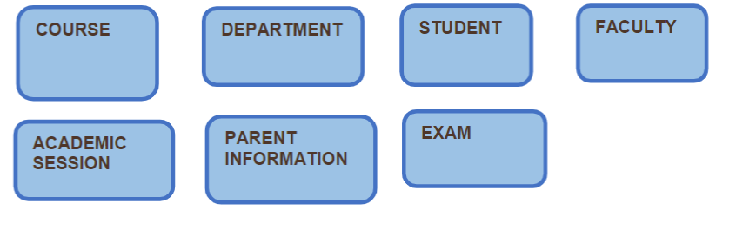

* indicates Mandatory (nulls are not allowed)

o indicates optional, (nulls are allowed)

Course:

* Faculty o
* Exam o
* Exam_Results o
* Exam_Timeline o
* Student_ID o
* Academic_Session o
* Department*

Department:

* Course *
* Academic Session o
* Exam o
* Exam_Results o
* Exam_Timeline o

Student:

* Student_ID *
* Parent_ID *
* Course o
* Academic Session o
* Exam_Results o

Faculty

* Department *
* Course o
* Academic Session o

Academic Session

* Course *
* Department *
* Faculty *
* Student_ID *

Parent Information

* Parent_ID *
* Student_ID *
* Academic Session *

Exam

* Academic Session *
* Course *
* Department *
* Exam Results *
* Exam_Timeline *
* Faculty *
* Student_ID*

Database Foundations

2-4: Unique Identifiers Practices

Exercise 1: Identify the Unique Identifier and corresponding Primary keys

Overview

In this practice you identify the unique identifiers and the corresponding primary keys from the given scenarios.

Tasks

1.How do you find a particular song in the whole collection? What would be a unique identifier for SONG?

2.Think about all the students in the classroom. Each student is described by several traits or attributes. Which attribute or attributes allow you to pick a single student from the rest of the class?

3.For each entity, select the attribute that could be the unique identifier of each entity.

Entity: STUDENT

Attributes: student ID, first name, last name, address

* Student ID

Entity: MOVIE

Attributes: title, date released, producer, director

* Title

Entity: LOCKER

Attributes: size, location, number

* Number

Exercise 2: Identify the Unique Identifiers and add to the ERD

Overview

In this practice, you will identify unique identifiers and add to an ERD.

Tasks

1.Use the Academic Database ERD from the previous exercises to identify the following:

a.Unique Identifiers

* Badge number, payroll number, student ID number

b.Candidate Unique Identifiers

* Email

Database Foundations

2-5 : Relationships Practices

Exercise 1: Identify relationships from the ERD

Overview

In this practice, you identify the relationships from the ERD diagrams and write the ERDish sentences.

Tasks

1.Read the relationship. Which text corresponds to the diagram?

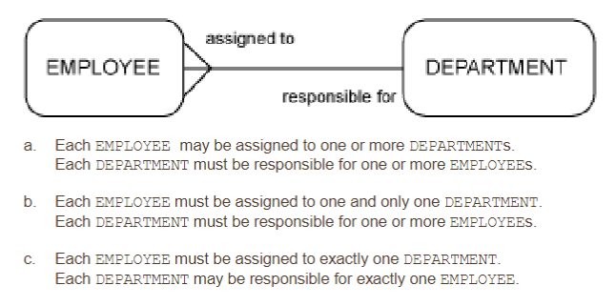

* B

2.Read each relationship in the model below. For each relationship, write the ERD statement and your comments. Use your knowledge of normal people and towns in your comments.

* One person is born in a town, one town is the birthplace of many people
* One person is living in the hometown of x town, the town of x is the hometown to many people
* One person is the visitor of a town, a town is visited by many people
* One person is the mayor of a town with many people, a town has one mayor governing over many people

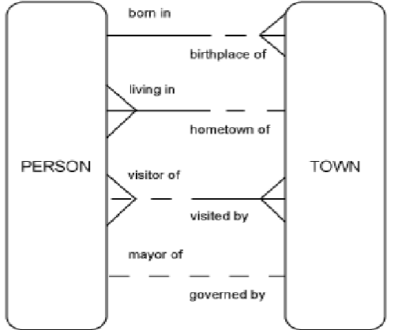

Exercise 2: Analyze and Model Relationships

Overview

In this practice, you analyze and model the relationships for the following entities, which you created in the Academic Database previously.

Tasks

1.Write the ERDish for each of the relationships in the Academic Database including relationship names, optionality and cardinality. Draw the ERD including the relationships

* A course has one ID number, and many people taking the course
* The department many courses taught in it, but each course is only in one department
* One student has one ID number, but many ID numbers represent many students
* One faculty member has one ID number, but many ID numbers represent many faculty members
* One faculty member is in one department, but a department has multiple faculty members
* There are many courses in an academic session, but there is only one academic session at a time
* Many exams have start dates, but each exam only has one start date
* There are many parents with ID numbers, but each parent only has one ID number

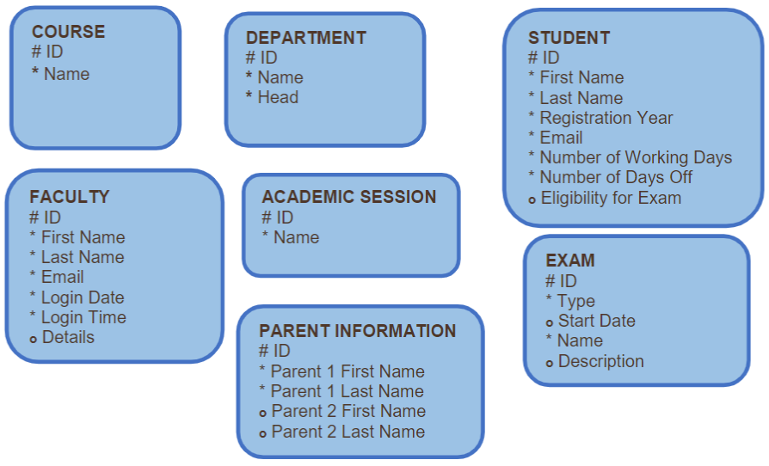

Database Foundations

2-6 : Entity Relationship Modeling (ERDs) Practices

Exercise 1: Identify the components in the ERD

Overview

In this practice you will identify the components in a given simple ERD.

Tasks

1.Identify the possible Entities and Attributes from the given scenario.

A company has several departments. Each department has a supervisor and at least one employee. Employees must be assigned to at least one, but possibly more departments. At least one employee is assigned to a project, but an employee may be on vacation and not assigned to any projects. The important data fields are the names of the departments, projects, supervisors and employees, as well as the supervisor and employee number and a unique project number.

* Entities:
  + Staff
  + Department
  + Project
* Attributes:
  + Staff: Staff Name, Supervisor, Employee, Current, On Vacation, Employee Number, Supervisor Number
  + Department: Department Name
  + Project: Project Name, Project Number

2.Read the given business scenario. Draw the entities HAIRSTYLIST and CLIENT. List the attributes associated with each entity and specify whether they are mandatory or optional. Identify the UIDs. Follow the diagramming conventions discussed. State the ERDish for the relationships.

* Entities:
  + Hairstylist
  + Client
* Attributes:
  + Hairstylist: First name, last name, address, phone number, SSN, salary, days worked
  + Client: hairstlyist preference, first name, last name, phone number, appointment date, hairstylist at appointment

“In our salon, we have a number of hairstylists. They are all salaried employees, so we keep a record of their first name, last name, address, phone number, social-security number, and salary. During the course of a day, a hairstylist may see several clients. On a slow day, a hairstylist may not work on anyone at all. We have several walk-in clients, and they each get assigned to one hairstylist. We just ask for their first name. We also have customers who call to make an appointment. When they do this, we ask for their first name, last name, and phone number. We also ask if they would like a specific hairstylist. If they have no preference, we assign one for them. Of course, they are allowed to switch to another hairstylist for their next visit to the salon. We are interested in tracking the daily appointments -- which stylist works on which client during a given day.”

3.Read the given business scenario. Draw the entities TEACHER and COURSE and CLASS. List the attributes underneath each entity. Specify whether they are mandatory or optional. Identify the UIDs. . State the ERDish for the relationships.

* Entities:
  + Teacher
  + Course
  + Class
* Attributes:
  + Teacher: First Name, Last name, address, phone number, email, course, status
  + Course: teacher, course name, code, section numbers, course ID
  + Class: curse ID, teacher, course name, section number, day, time, classroom

A course can be taught by many teachers, and many teachers can teach a section of that course

A course can have many classes, but each class is a part of one course ID

Many classes have a course ID, but each course ID is for one course

Many teachers have emails, but each teacher has only one email address

“We have several teachers at our school. A teacher can be assigned up to three classes per semester. If a teacher is on sabbatical, he doesn’t teach that semester. We keep a record of the teacher’s first name, last name, address, phone number, and email address.

Our school offers many courses -- such as Data Modeling, Introduction to SQL, Trigonometry, Physics, and Biology. Each course has a code. For example: Data Modeling would be DM001, Trigonometry would be TR004, etc. During each semester, a course may be taught in several classes -- so there could be two classes of Physics, three classes of Biology, etc. Each class can be taught by only one teacher. We assign a unique ID for each class, and we also keep track of the day it is taught, the time, and the classroom.”

Database Foundations

3-1: More with Relationships Practices

Exercise 1: Resolve M:M Relationships

Overview

In this practice, you will resolve the following M: M relationships within the Academic database. Add additional attributes in the intersection entities where needed.

* 1: create an intersection entity with identifying relationships to the originating entities. Create an intersection of dates to host the course’s exam
* 2: create an intersection of students taking the course taught by the professor
* 3: I don’t understand the need to resolve this relationship

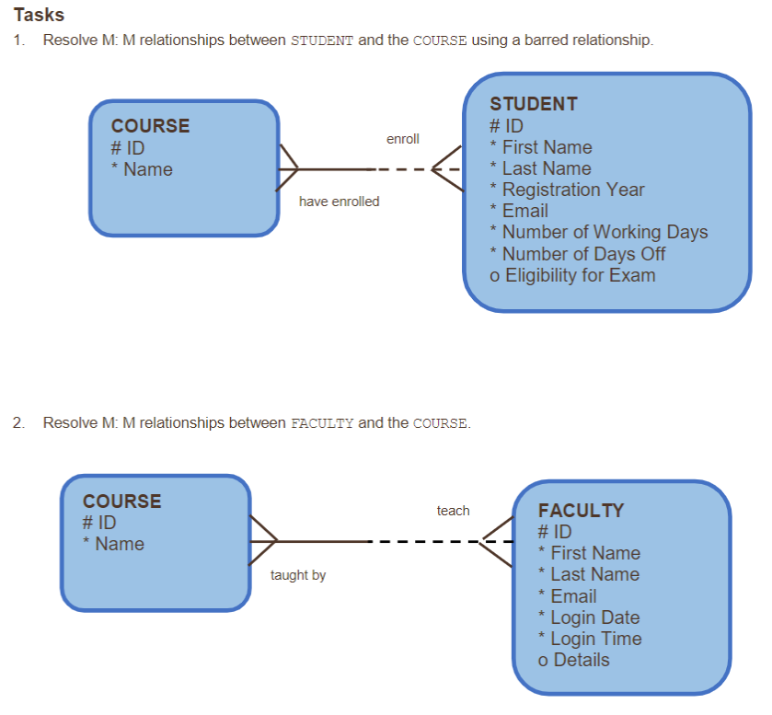

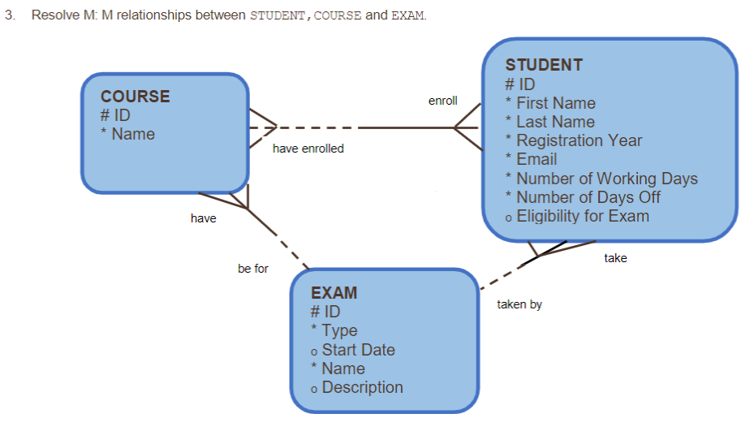

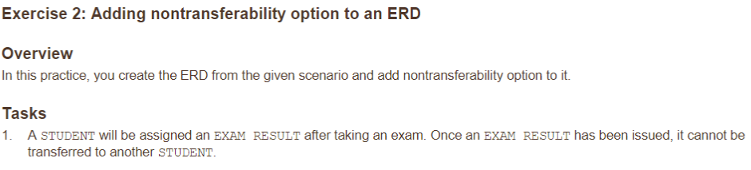

Student —> - - - - - Exam Result

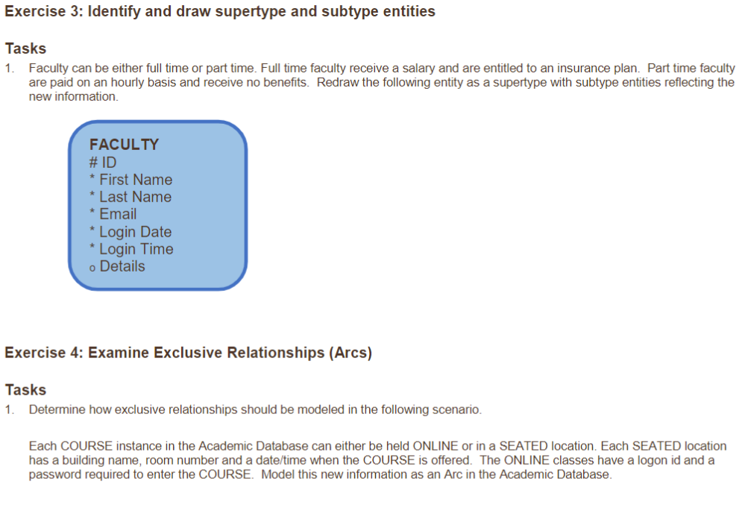

Full Time Faculty —- salary & insurance plan

Part time Faculty —- hourly pay & no benefits

Seated—----------------Course —--- online

Building name login ID

Room number password

Date

Time

Floors

Suites

Rooms

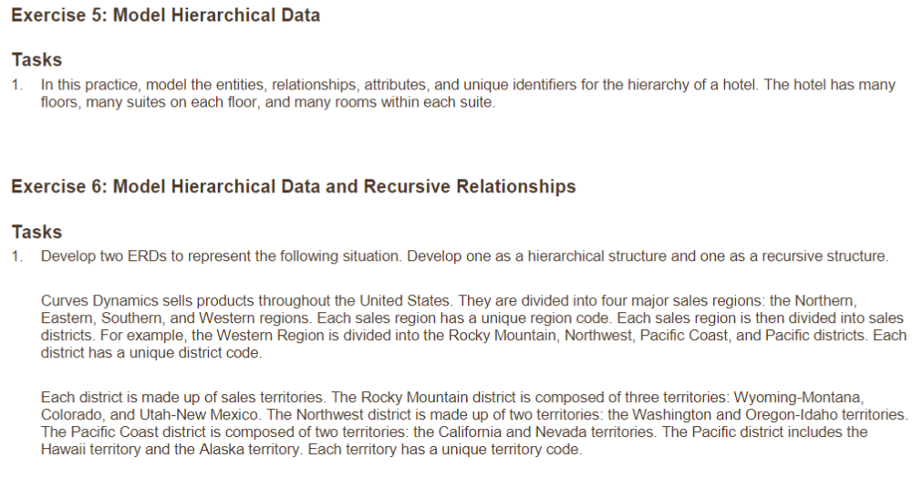

Hierarchical:

Curves Dynamics

Sales Regions

Sales Districts

District Codes

Sales Territories

Recursive:

Curves Dynamics

Sales Regions: Northern, Eastern, Southern, Western

Sales Districts:

Northern:

Eastern:

Southern:

Western:

Rocky Mountain

Wyoming-Montana,

Colorado (Front Range & Western Slope)

Utah-New Mexico

Northwest

Washington, Oregon-Idaho

Pacific Coast (Hawaii, Alaska)

Pacific districts

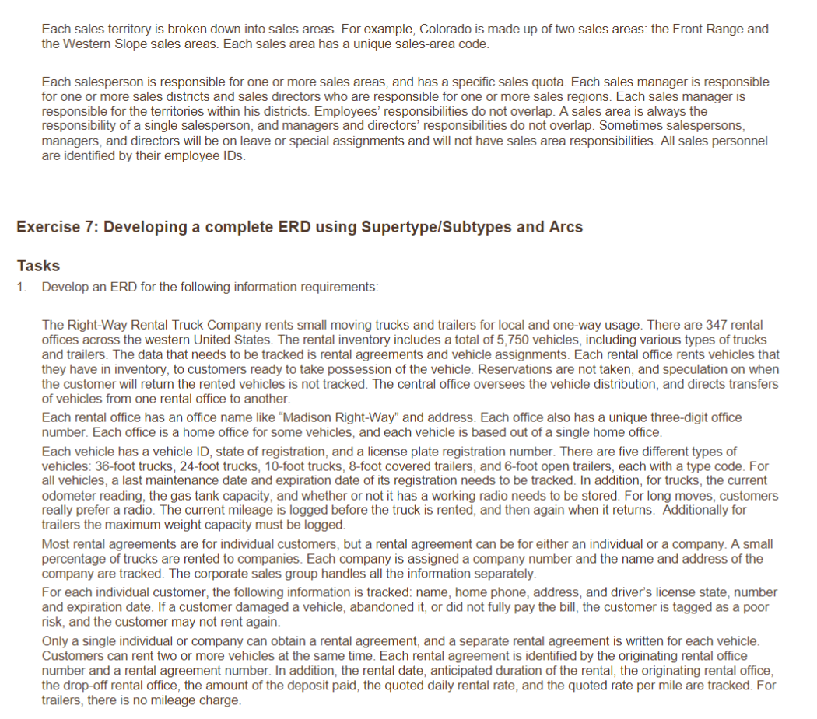

Right-Way Rental Truck Company

Rental Agreements

Madison Right-Way Office Number

Rental Agreement number

Starting odometer

Ending odometer

Customer Name

Rental Date

Anticipated duration of rental

Originating rental office

Drop off rental office

Amount of deposit paid

Quoted daily rental rate

Quoted rate per mile (trucks only)

Customer Information

Name

Home phone

Address

Driver’s license state

Driver’s license number

Driver’s license expiration date

Customer Risk Assessment

Damage

Abandoned vehicle

Bill Not Paid in Full

Number of Rentals at this time

Vehicle Assignments

Vehicle ID

State of Registration

License plate registration number

Vehicle Type

36-foot trucks

24-foot trucks

10-foot trucks

8-foot covered trailers

6-foot open trailers

Last maintenance date

Registration expiration date

Odometer reading (trucks)

Gas Tank Capacity (trucks)

Radio Status (trucks)

Maximum weight (trailers)

Database Foundations

3-2: Tracking Data Changes

Practices

Exercise 1: Track Data Change over Time

Overview

In this practice you use scenarios to identify data that changes over time and construct ERD models that incorporate the element of data over time.

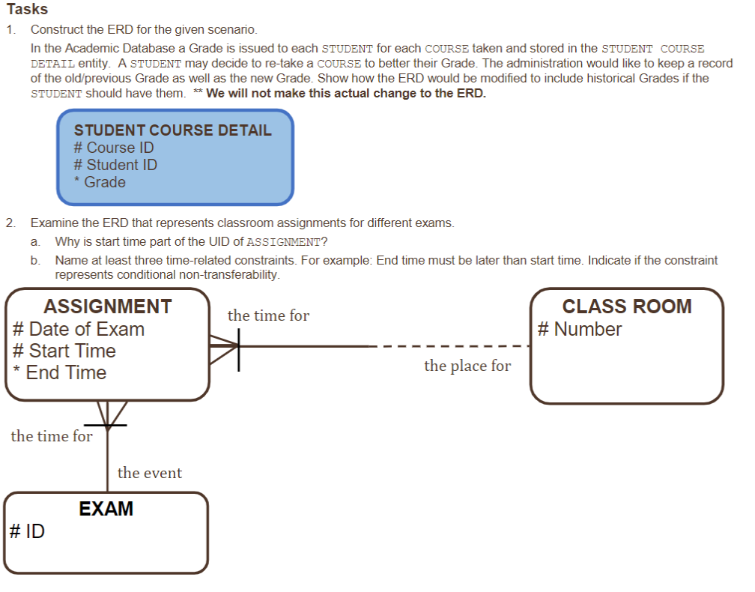

* The start time is part of the UID so that administration can track if students are retaking the course to better their grade.
* Time of exam cannot be same as another time of exam for one student, class room number cannot be the same as another classroom as the same time as another exam, one student cannot be assigned to the same exam for the same course at the same time more than once.

Database Foundations

3-3: Normalization and Business Rules

Practices

Exercise 1: Relational Databases

Overview

In this practice you will analyze the given table structure and bring the table to the specified normal form.

Tasks

1.Analyze the given table which is not normalized. The table holds information specific to items such as the Item ID, Color of the item, and the Unit price of each of the item. Some of the rows in the table have repeating group of information. Evaluate the data in the table and bring the table to first normal form

* 1. Each item ID should indicate ONE color, not two. As per the first normal form rule, all attributes must be single-valued. Blue should have its own Item ID
* 2. Second normal form indicates that an attribute must be dependent on its entity’s entire UID. The issue with table 2 is that there are multiple locations assigned to a store ID, and multiple Store IDs and locations assigned to a supplier ID
* 3. In this table there are multiple category descriptions with the same category ID, but with varying prices.

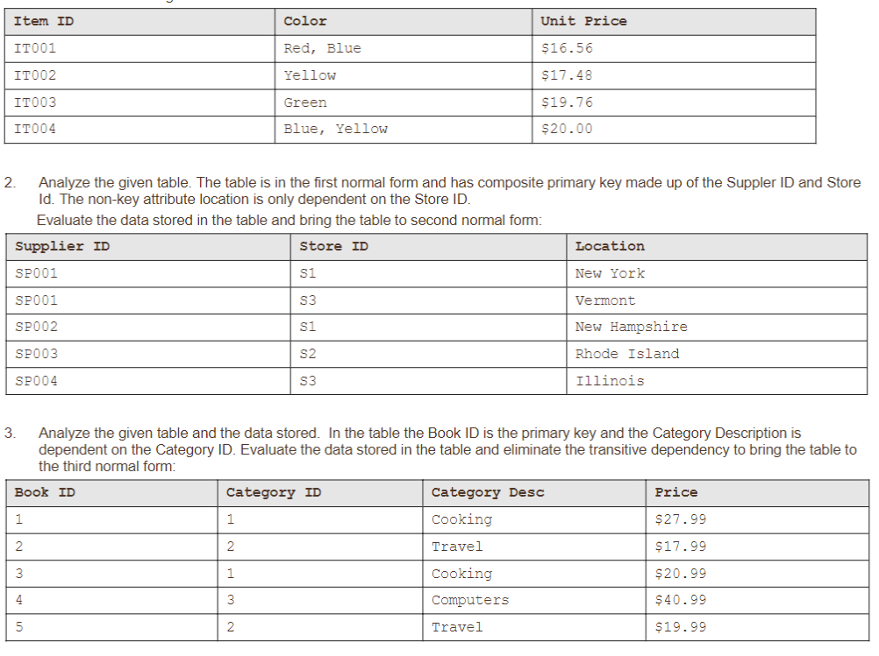

Copyright © 2020, Oracle and/or its affiliates. All rights reserved. Oracle and Java are registered trademarks of Oracle and/or its affiliates. Other names may be trademarks of their respective owners.

2

Exercise 2: Normalize Academic Database ERD

Overview

In this practice, you use un-normalized database models to create normalized database models.

Tasks

1.For the Academic Database ERD, evaluate each entity against the rules of normalization, identify the misplaced attributes, and explain which rule of normalization each misplaced attribute violates.

* Why are there working days and days off for students? Should that be in Faculty?
* Student should have Academic session underneath them

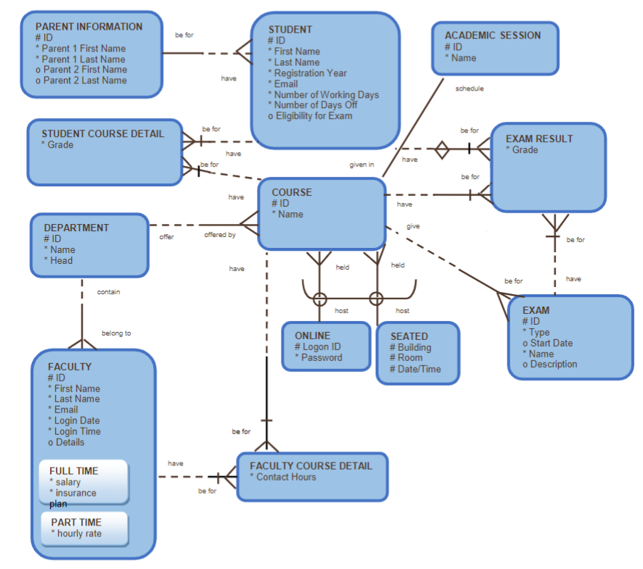

Exercise 3 task 1

* There are repetitive lines for the same user ID and user name
* There are repeated message ID codes & Subjects but under different users
* There are several columns that are the same for each user, creating a lot of information to look at but once you read through it, realize it’s all for the same user identification. Move all of those UserIDs columns to their own entity about the User

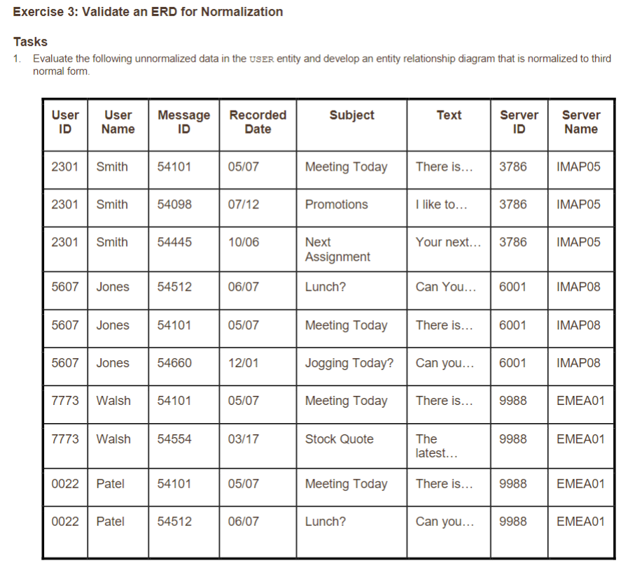

Task 2

* Should paint color and interior color be placed under color scheme in a new entity as part as the third normal form

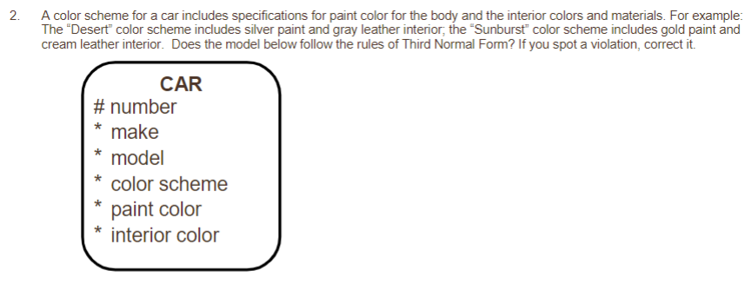

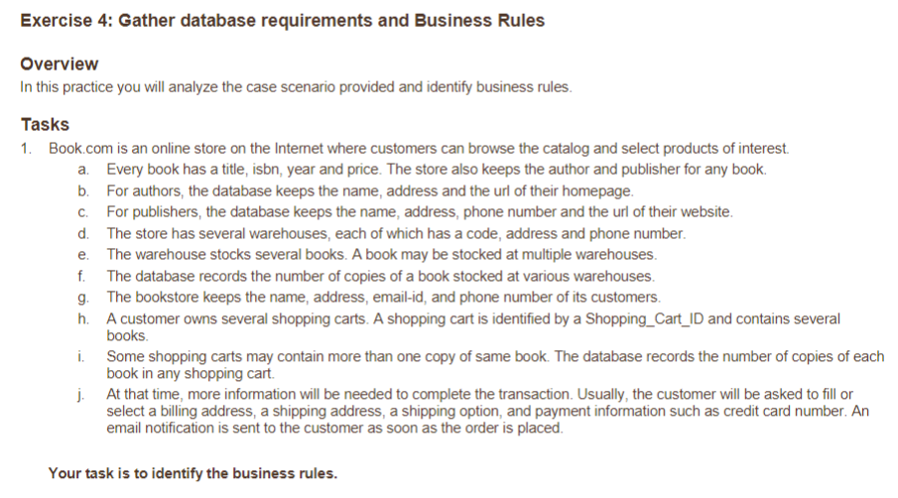

1. Business Rules:
   1. Books: title, isbn, year, price, author, publisher, warehouse where stocked, quantity
   2. Authors: name, address, URL, books
   3. Publishers: name, address, phone number, URL, books published, authors published
   4. Warehouses: code, address, phone number, book titles, quantity
   5. Customers: Name, address, email, phone number, shopping cart ID, quantity, billing address, shipping address, shipping option, payment information, email notification

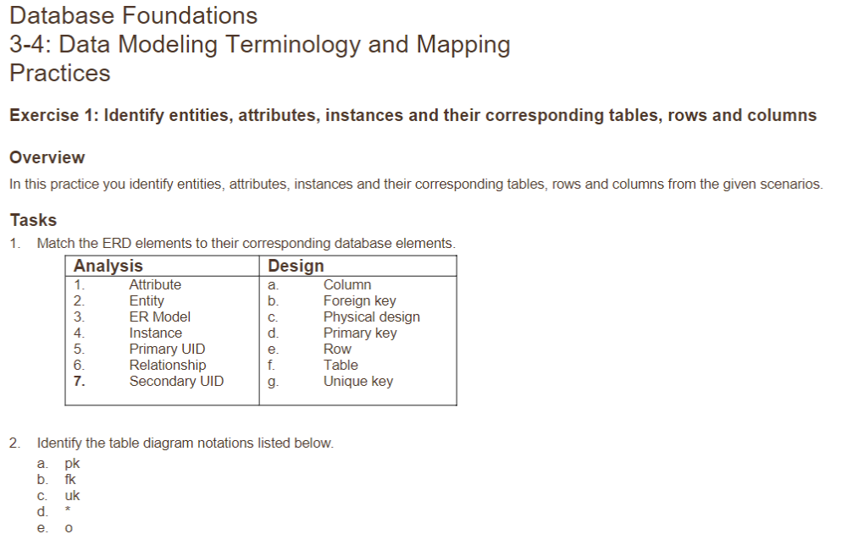

1. Attribute: a. Column
2. Entity: f. Table
3. ER Model: physical design
4. Instance: e. Row
5. Primary UID: primary key
6. Relationship: foreign key
7. Secondary UID: unique key

Pk - primary key

Fk - foreign key

Uk - unique key

* - mandatory, no nulls allowed

o - optional, nulls allowed

3. ATR

4. PLE

3. CTM

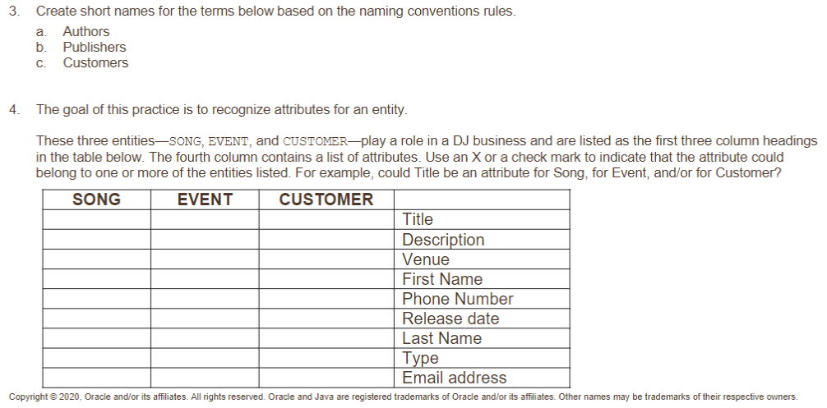

X x x

X x

X

X

X x

X

X x x

X

Exercise 2: Mapping the Academic Database

Overview

In this practice you identify entities, attributes and their corresponding tables and columns from the given scenario.

Tasks

1.With the ERD provided below, map the entities, attributes and UIDs to tables, rows, and keys using a table diagram as shown

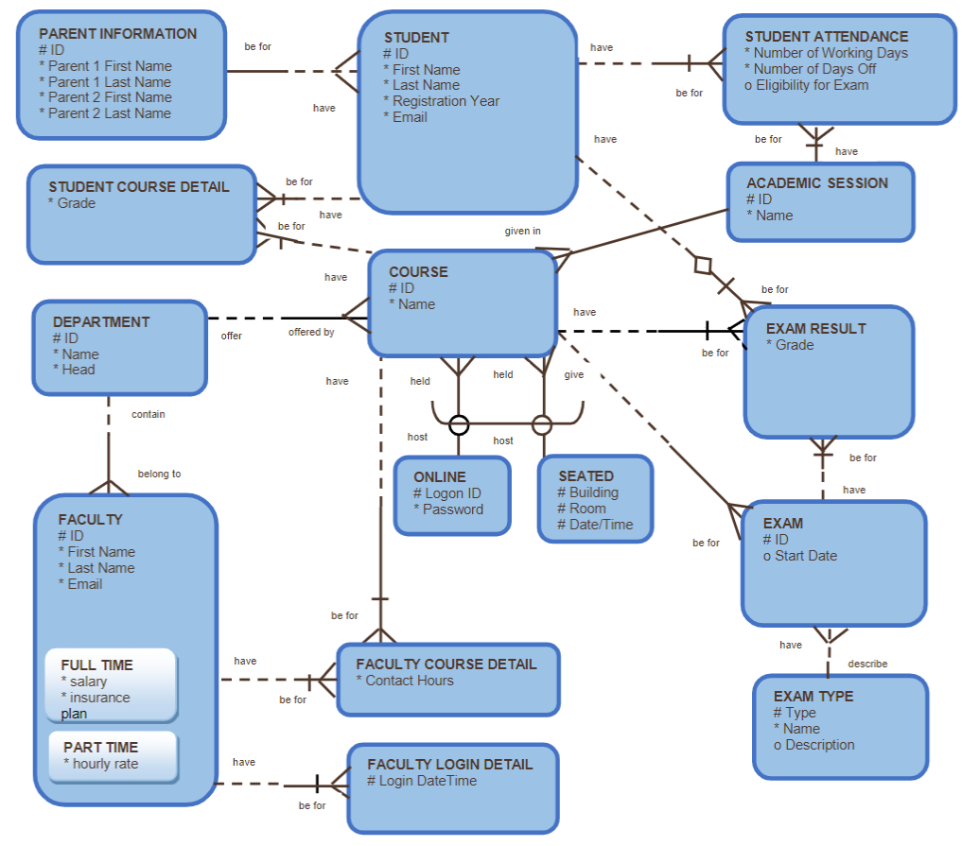

PR1

PR2

SD Name

SD ID

Reg Year

EM

SD ATD

GR

EXR

EXT

CRS ID

CRS Name